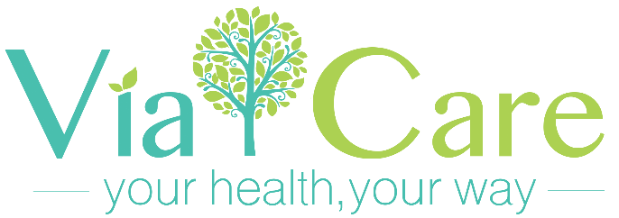

DONATION FORM

Donations can be made by filling out this form and return it to Via Care.

Title Dr Mr Mrs Ms Other / Name________________________________________

Address____________________________________________________________

City_____________________________ State__________ Zip_________________

Phone____________________________ Email_____________________________

Method of Payment
Cheque or money order (payable to Via Care Community Health Center)

Please accept my donation of $________________________

Please mail to:

Via Care Community Health Center
Attn: Development Department
501 S. Atlantic Blvd.
Los Angeles, CA 90022

A confirmation email and letter of appreciation of your tax-deductible contribution will be mailed to you at the address you provided.

We thank you for recognizing that the investments we make in the community of East Los Angeles are worthwile and critical to building a more equitble and healthy society.

Tax ID # 80-0699156

